
‘

Group Member: M Sarmad Khan (SP23981)
Malik Haseeb (SP23980)

Class: BSSE-4-AFTERNOON

Project: Online Ticket Booking Management System

Subject: Database Management system

Submitted to: Mam Meher Nisa

Date: 02-01-2025

Project Report

1. Introduction
The Online Ticket Booking System is designed for managing bus ticket bookings for customers. It enables users to search for available buses, book seats, make payments, and manage ticket details. Bus operators and administrators can manage buses, routes, schedules, and payments efficiently through the system.

2. Database Structure
The database consists of multiple interrelated tables to manage data for customers, buses, routes, schedules, tickets, and payments. Here's a summary of each table:
- Customers Table: Contains customer information such as ID, name, email, phone number, and address.
- Buses Table: Stores bus details including bus number, type, capacity, and the operator's name.
- Routes Table: Details the different routes with origin, destination, distance, and duration.
- Schedules Table: Links buses to routes, and includes details like departure time, arrival time, and price.
- Seats Table: Manages seat availability for each schedule, including seat numbers and their status (available or booked).
- Tickets Table: Contains information about the tickets booked by customers, including the schedule, seat, and ticket price.
- Payments Table: Records payment transactions for the tickets, including the method, date, and amount.
Table 1: Customer Table
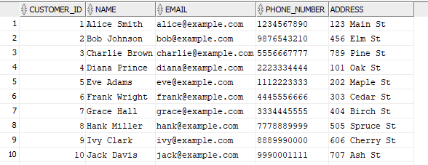
Table 2: Bus Table
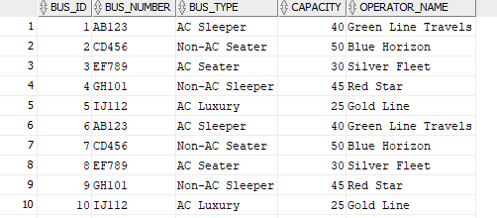

Table 3: Routes Table
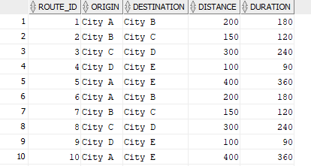
Table 4: Schedule
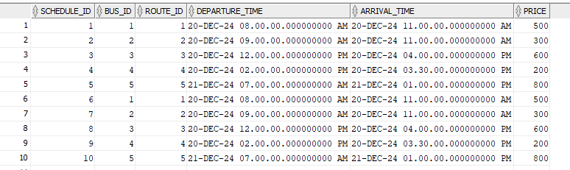

Table 5: Tickets Table
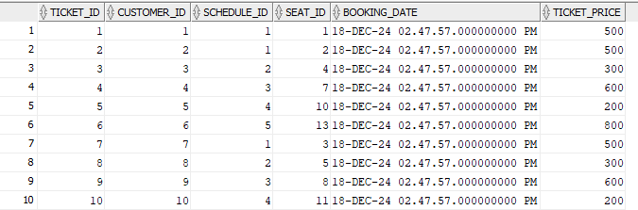

Table 6: Seats Table
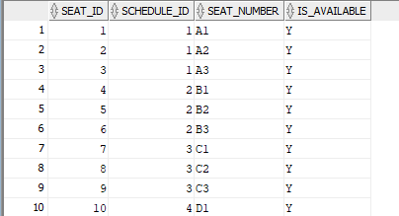
Table 7: Payments Table
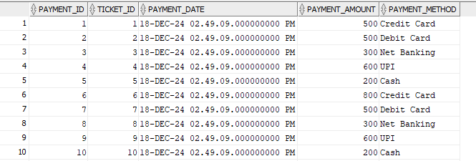

3. SQL Queries
Various SQL queries were written to retrieve data from these tables, using different types of joins:
- LEFT JOIN: Retrieves customers and their tickets, even if they have not booked one.
- RIGHT JOIN: Retrieves tickets and their associated customer details, even if the ticket is unlinked.
- FULL OUTER JOIN: Shows all customers and tickets, even if some customers haven't booked a ticket or some tickets are unlinked.
- INNER JOIN: Retrieves customers who have booked tickets along with their ticket details.

Query 1: Left Join
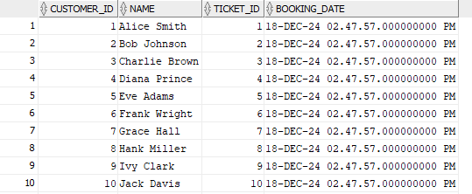
Query 2: Right Join
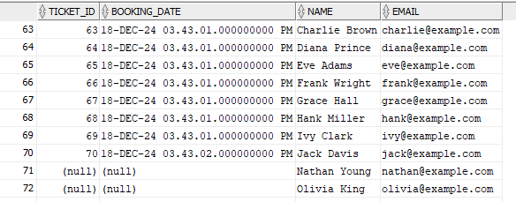

Query 3: Full outer Join
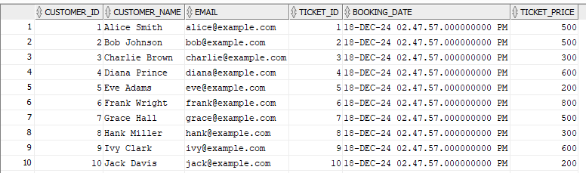
Query 4: Inner Join
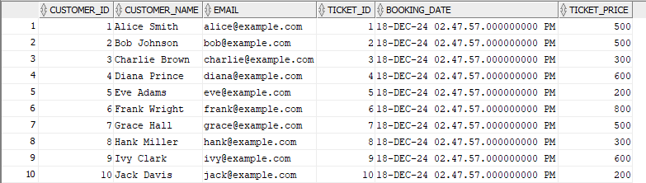

Conclusion
The Online Ticket Booking System is a robust database management system designed to handle bus ticket reservations and associated processes efficiently. By integrating multiple tables, the system provides a seamless flow of information between customers, buses, routes, schedules, seats, tickets, and payments.
Key features include:
- Customer Management: The system allows customers to book tickets, manage personal details, and track their booking history.
- Bus and Route Management: Operators can manage different types of buses, their capacities, and assigned routes, ensuring that the system can handle various travel options.
- Ticket Booking and Payment: Customers can book tickets for specific schedules, select available seats, and make payments through multiple methods. The system records payment transactions, ensuring smooth financial tracking.
- Efficient Data Retrieval: By utilizing SQL queries with different types of joins, the system ensures that all relevant data can be accessed efficiently, whether for customer queries or administrative tasks.

